

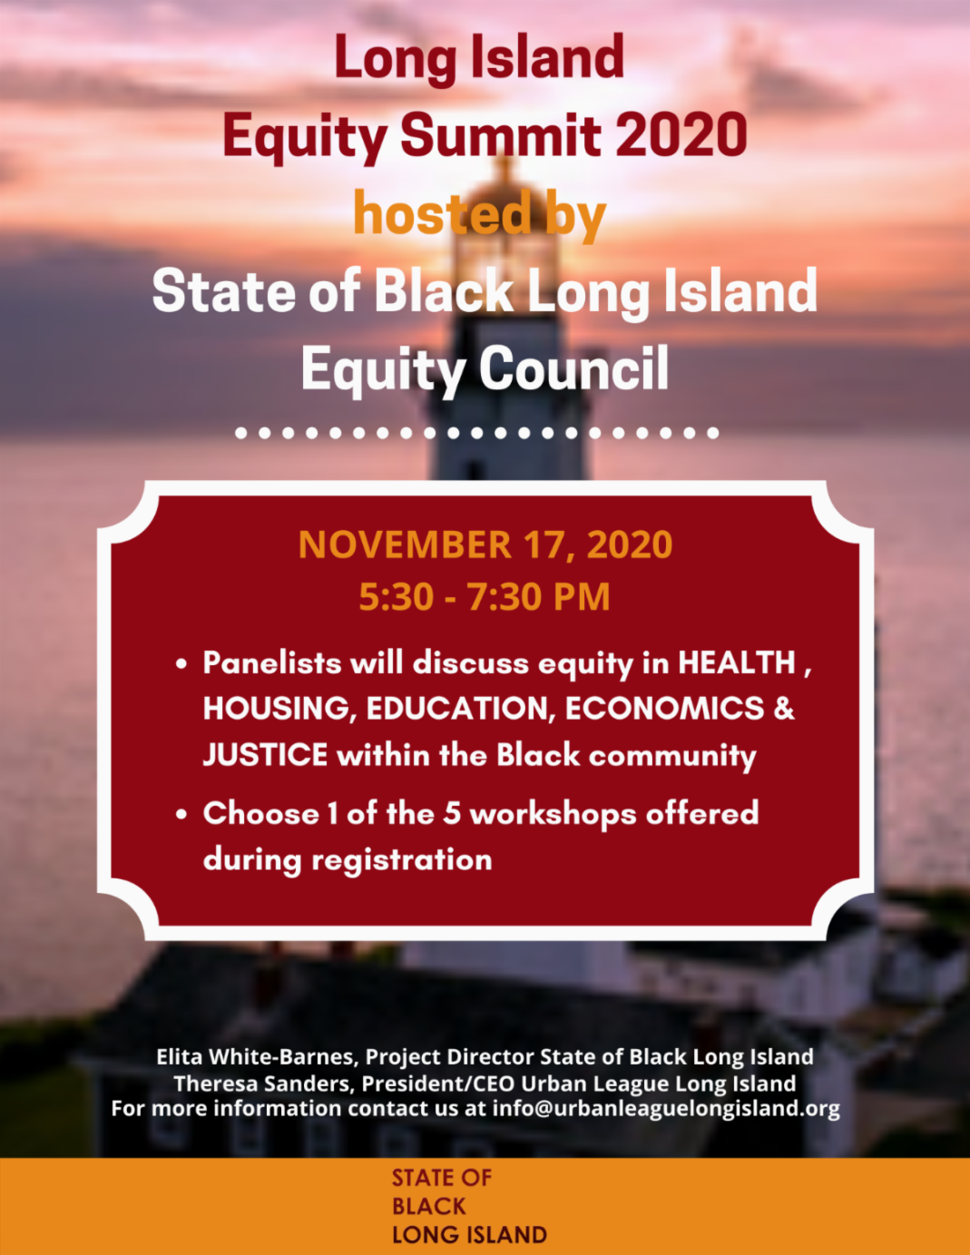

The State of Black Long Island Equity Council (SOBLI) has joined with local leaders to provide a solution driven conversation about equal and fair practices across Long Island. We are excited to share with you what SOBLI has accomplished in 2020 and our strategic direction for 2021. This conference style event is free to all participants.

Here are our five workshop topics:

- Equity During the Pandemic
- Building Wealth Through Homeownership
- Police Reform and Reinvention
- Access to Economic Equity
- Coping with the Stress of the New Normal

Send your questions for the panelists to info@urbanleaguelongisland.org

To Register Click Here

Please feel free to share this information with your network.

Connect with us
‌ ‌

